AM Affiliates List:
Effigy Designs, Orillia
Logo Design and Stickers
1.705.345.7735
http://www.effigydesign.ca/

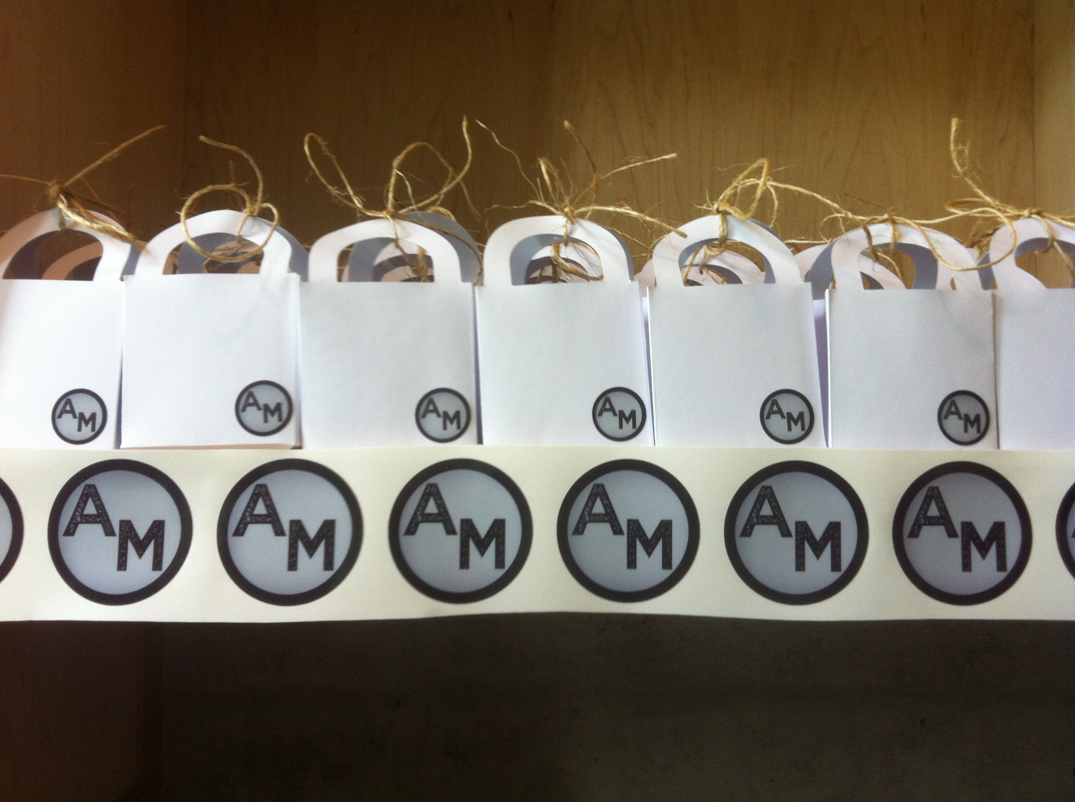
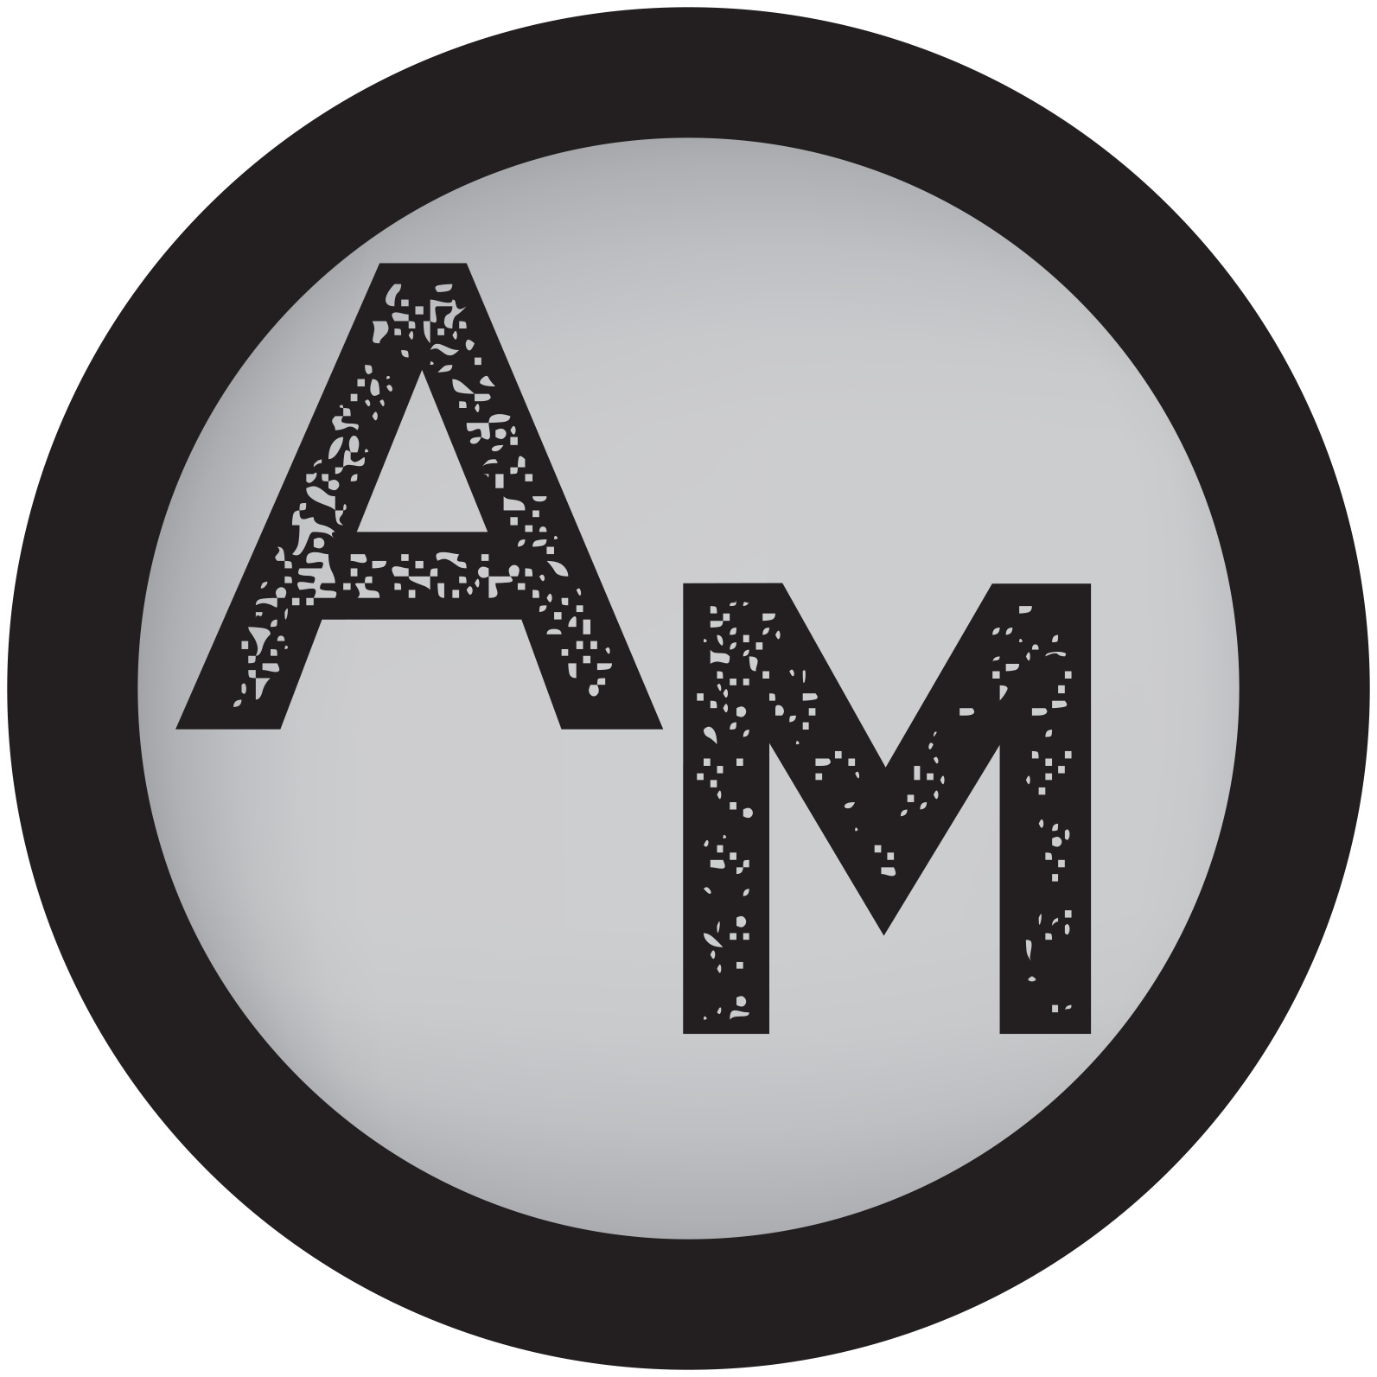

4imprint Canada, Canada
Wooden Tokens
1.800.300.1336
http://www.4imprint.ca/

